|  |
| --- |
| **Awarding Body:** Arden University |
| **Programme Name:** BSc(Hons) Computing |
| **Module Name (and Part if applicable):** Web Design |
| **Assessment Title:** Web Design |
| **Student Number:** STU67082 |
| **Tutor Name:** Mafeez Bi |
| **Word Count:**  2875 |

**Task 1**

**Case Study Word Count: 283**

For my website I would like to have a simplistic style and simple navigation section which is friendly to beginner and intermediate web users. My website will be based more on information that fun and interactive. There is many different styles and colour schemes in the websites that I looked at, this website (<http://letzgogreen.org/>) has many different colours and is more attended to kids. I am going for the more mature audience like the children’s parents and planning on having a few simple colours for a more professional and easier to access website like this: (<http://www.ourladyoflourdesprimary.com/>)I am going to keep a simple dark colour scheme throughout my website While looking at all the primary school websites I have noticed that most of the navigational features are along the top or in the middle like this: (<http://www.st-matthews.bham.sch.uk/>). I on the other hand would like to have the navigational features on the left-hand side like a list with a nice neat border around them. I will have the left side of the page with information and the right side of the page a nice clear picture. I have a different idea for the main page which will have a picture on the left along with a picture on the right. I think in doing this it will make the home page stand out as a home page more than the rest. The language scheme through my website will be informational along with being formal.

I plan to have many pages to my website to achieve the best marks possible, so far, I have six pages planned out on my website, these will include: Home, About Us, Lessons, After School Activities, Term Dates, and Contact us.

**Task 2**

**Background Research Word Count: 586**

|  |  |  |  |  |
| --- | --- | --- | --- | --- |
| **Website** | **Design** | **Usability** | **Functions** | **Accessibility** |
| www.billesley. bham.sch.uk/ | . Simple Design  . Same colour scheme throughout  . Same Font through the website | . Clear English  . Good layout  . Nice clear sections and easy to understand  . See social media posts from the site  . Icons you can click on | . Menu bar on top right  . Clickable pictures that brings you to the page you want  . Hyperlinks that bring you to desired page  . Search bar  . Option for newsletter | . No zoom option  . Has translation option  . Alt text for images |
| www.stchads primary.co.uk/ | . Simple design  . Different colour schemes  . Different fonts | . Clear English  . Layout is good on parts of the website  . Some of the website is poorly laid out  . Weekly letters available to public  . Working Hyperlinks | . Navigation bar  . Weekly letter download option  . Downloadable prospects and admissions  . Search option | . Translation option  . Alt text for images |
| www.stgnewtown .bham.sch.uk/ | . Simple design  . Good colour scheme  . Different fonts  . Welcoming homepage | . Clear English  . Working links  . Events on main page  . Layout is good  . Easy to navigate | . Navigation bar  . Search option  . Events  . Drop down menus | . Translation option  . Alt text for images  . No zoom option |
| www.brookfields .bham.sch.uk/ | . Simple design  . Very good homepage  . Different fonts  . Lots of colours that complement each other | . Clear English  . Working links  . Easy to navigate  . Everything accessible on main page | . Search bar  . Scrolling information at the top of page  . Navigation at top and side | . Translation option  . Alt text for images |
| www.chandos primary.org/ | . Simple design  . Different fonts  . Bright colours  . Same colour scheme | . Clear English  . Working links  . Very good layout  . Easy to navigate | . Search bar  . Different  . Language menu  . Social media on page  . Navigation menu | . Translation option  . Alt text for images  . Language option |
| [www.angleseysch-bham.co.uk/](http://www.angleseysch-bham.co.uk/) | . Simple colour scheme  . Good home page  . Same fonts | . Video playing as the background  . Easy to navigate  . Clear English | . Option to pause background video  . Navigation menu  . Search bar  . Scrolling information | . Translation option  . Alt text for images |
| www.ladypool. bham.sch.uk/ | . Same colour scheme  . Same fonts  . Good layout | . Clear English  . All information is in the middle section | . Social media visible on page  . Search bar  . Navigation menu  . Usable map on page | . Translation option  . Alt text for images |
| www.stfranrc. bham.sch.uk/ | . Same colour scheme  . Simple design  . Not the best layout | . Clear English  . Useful information  . Social media on page  . A bit more difficult to navigate | . Navigation menu  . Quick links  . Scrolling information  . Different language option | . Translation option  . Alt text for images  . Different languages |
| www.stvincents bham.co.uk/ | . Not the best colour scheme  . Simple design  . Simple layout | . Clear English  . Easy to navigate  . Easy to understand | . Different language options  . Navigational menu  . Privacy Notice available | . Translation option  . Alt text for images  . Different language |
| www.harperbellsda school.co.uk/ | . Good colour scheme  . Good layout  . Good design | . Clear English  . Easy to navigate  . Well placed pictures  . Well placed information | . Navigation menu  . Join school on main page  . Meet teachers option | . Translation option  . Alt text for images  . No language option |

**Task 3**

**Web Planning Word Count: 718**

For layout and planning I have completed a wireframe to map out the design that I would like to go for. I am going for the same design throughout all the website apart from the home page. I also have completed a site map to show the different navigation options on my website.

**Site Map**

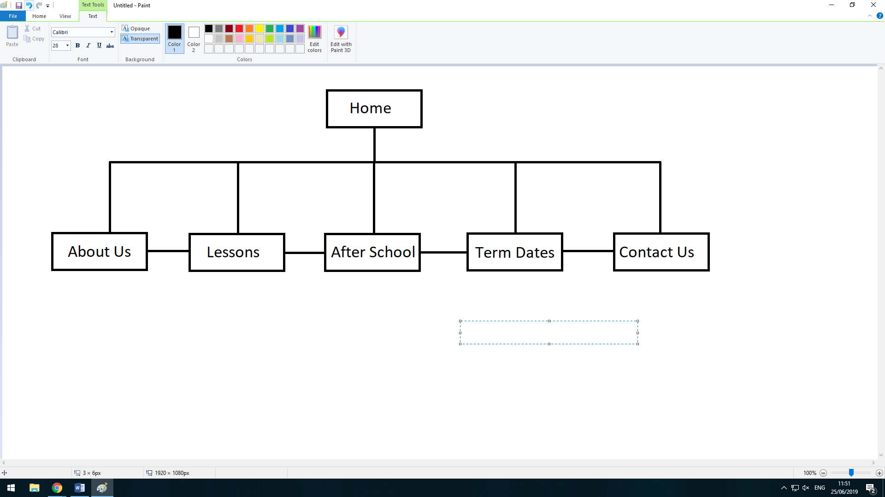

Here is the sitemap of my website, it’s very basic but very simple. The home page connects to all the other pages and all the other pages can connect back to the home page. You can also be on the lessons page and connect to after school by clicking the page. You can connect all the any page while being on any page. Every page is connected to all available pages. This is a hierarchical design and not a linear one. This design is much preferred by many sites which is why I have decided to use it.

**Home Page**

After researching a lot of websites I found that almost all of the school websites had a navigation bar at the top of the page. Where this is nice and easily accessible I would like my website to be different so I have opted to have the navigational bar on the left of the screen in the form of a list. I think this will still offer easy access to all the other pages. This is the only page that will have 2 images for the content. I will do this to signify that you are at the home page.

This box will include the social media links via hyperlinks.

This is the school’s logo which I will design myself either in Photoshop or paint.

Each box will have its own background colour keeping in mind of a simple colour scheme.

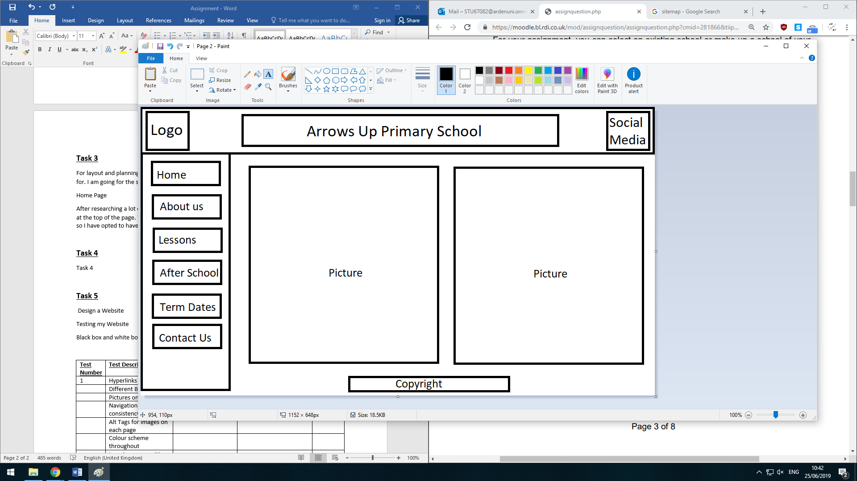

For the Home page there will be 2 appropriate pictures that will make the webpage seem more welcoming.

Each box has a hyperlink to a different page of my website.

Title will stay the same throughout.

This is the copyright section.

The background will stay the same throughout the website.

**About us, Lessons, After School, Term Dates, Contact Us**

These pages will be different to the homepage as this page will not include two picture on the page, it will only have on picture to the right and then a subheading and the information in a paragraph layout. Everything is the same as last Home page apart from the second picture located on the left.

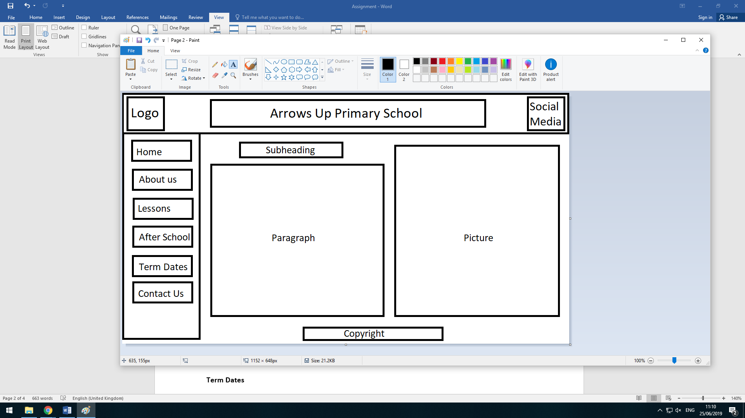

Here will be the subheading for the page

Here will be the information base on what the subheading is.

I will be going for a more professional look with this website. I will be using grey as a background as this give me the option to use almost any font colour without an issue. The top background which is behind the title, logo and social media will be a dark grey, with the dark grey background I will have the title in big bold writing and the colour white so it stands out more. The navigation menu will have a lighter tone of grey than the title background. In the navigation bar each hyperlink will have a black border around the link with a white background, the text inside will be black. This will stay the same throughout the whole website. The things that will change will be the content on each page, this will include a picture, paragraph of information or a list and a subheading. The sub heading will be bold and slightly bigger than the information below it so you know when it’s a heading. The subheading and the text below will be black. The pictures on each page will all be the same in height and width. I will be using a certain font throughout the website which will be Comic Sans MS which has a nice professional look to it and is easy to understand. I will also be adding an alt tag to each image which is an accessibility feature. In the top bar there will be a social media section with hyperlinks to YouTube, Twitter, Facebook and the contact email. Before making my website I will create accounts to the social media websites just for this website so when you click it you will come to the school’s social media.

**Task 4**

**Web Design Word Count:**

My Website:

I created my website with a programme called SublimeText, this is like a better version of notepad which allows you to edit many pages and CSS sheets at the same time and has cool features like automatically closing the tags you open.

Most of the websites in Task 2 have an abbreviated version of their school name along with bham at the end. I will be doing the same thing.

When choosing the web hosting provider I looked at some reviews of certain free webhosting pages and I went with a website called GitHub which was highly reviewed and came highly recommended from my fellow students as it was their choice too.

**Task 5**

**Implementation and Testing Word Count: 880**

I am going to black box test my website in the form of a table listing the test number, test description, expected result, actual result and if it works. “A tester, without knowledge of the internal structures of a website, tests the web pages by using a browser; providing inputs.” - (<http://softwaretestingfundamentals.com/black-box-testing/>)

|  |  |  |  |  |
| --- | --- | --- | --- | --- |
| **Test Number** | **Test Description** | **Expected Result** | **Actual Result** | **Works Yes/No** |
| **1** | Hyperlinks | Navigate to the correct location. | Navigated to correct page throughout the website. | **Yes** |
| **2** | Pictures on each page | Load correctly and in the proper proportion. | When loaded the pictures was in the correct place and same size throughout | **Yes** |
| **3** | Navigation bar position consistency | Positioned in same place throughout the website. | The navigation bar stays in correct location throughout the pages and doesn’t move out of place. | **Yes** |
| **4** | Alt Tags for images on each page | Show when picture does not load up | I loaded the page with incorrect link for the picture to see if the alt tags show and they do. | **Yes** |
| **5** | Colour scheme throughout | Consistent colour scheme and no errors. | The colour scheme stays the same all the way through the website and doesn’t change or glitch. | **Yes** |
| **6** | Logo in same position throughout | Appears in the same position and no errors or misplacements. | The logo stays in the same position all the way through. | **Yes** |
| **7** | Text in the correct position. | Appears in the same location throughout and subtitle too. | The subtitles and the paragraphs of information are in the correct position. | **Yes** |
| **8** | Same font size for titles, subheadings and paragraphs and font throughout. | Same for each throughout website. | The title font size stayed the same along with the subheading font size and paragraph size and the font stayed the same throughout. | **Yes** |
| **9** | Works in Google Chrome | Load each page correctly. | Loads perfectly in Google Chrome | **Yes** |
| **10** | Works in Microsoft Edge | Load each page correctly. | Loads everything great in this browser. | **Yes** |
| **11** | Copyright appears and stays in same location. | Shows on each page and in same position. | The copyright appears on each page and is in correct position. | **Yes** |

**Page 1:**

Page 1 is my Home page and consists mainly of informational pictures and Navigational features.

I have created a LOGO for my website as it matches up with the school name.

This is the Title

This is the school logo that I created with paint.

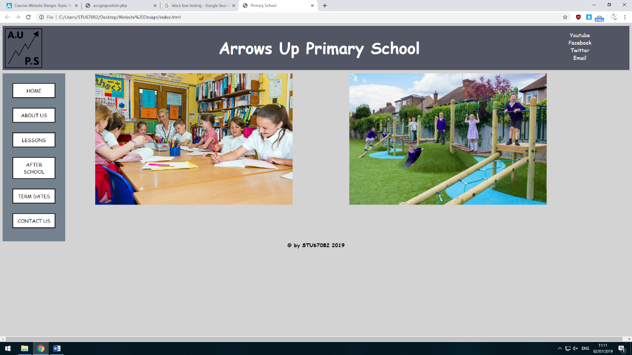

Links to social media for the school.

Copyright for my website.

Informational picture with an alt text for each image.

This is the navigation bar used to navigate through out the pages.

**Page 2**

Page 2 is the about us page which gives some general information about the primary school.

There is social media links on each page because most of today’s population all use social media.

This is the school logo that I created with paint.

This is the Title

This is the sub heading

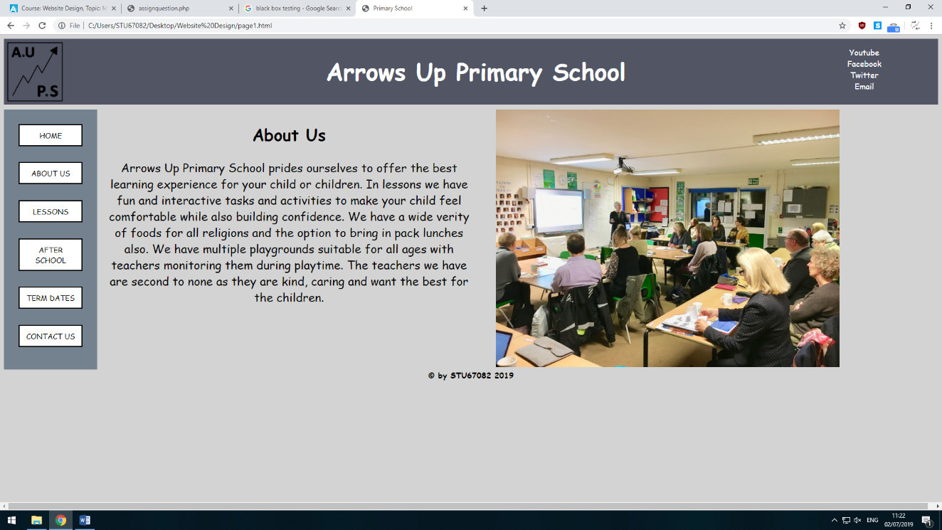

Links to social media for the school.

This is a paragraph of information regarding the subheading.

Informational picture with an alt text for each image.

Copyright for my website.

This is the navigation bar used to navigate through out the pages.

**Page 3**

This page has information regarding lessons and activities.

I added a copyright to my website to make sure no one copy’s or steals my design.

This is the school logo that I created with paint.

This is the Title

This is the sub heading

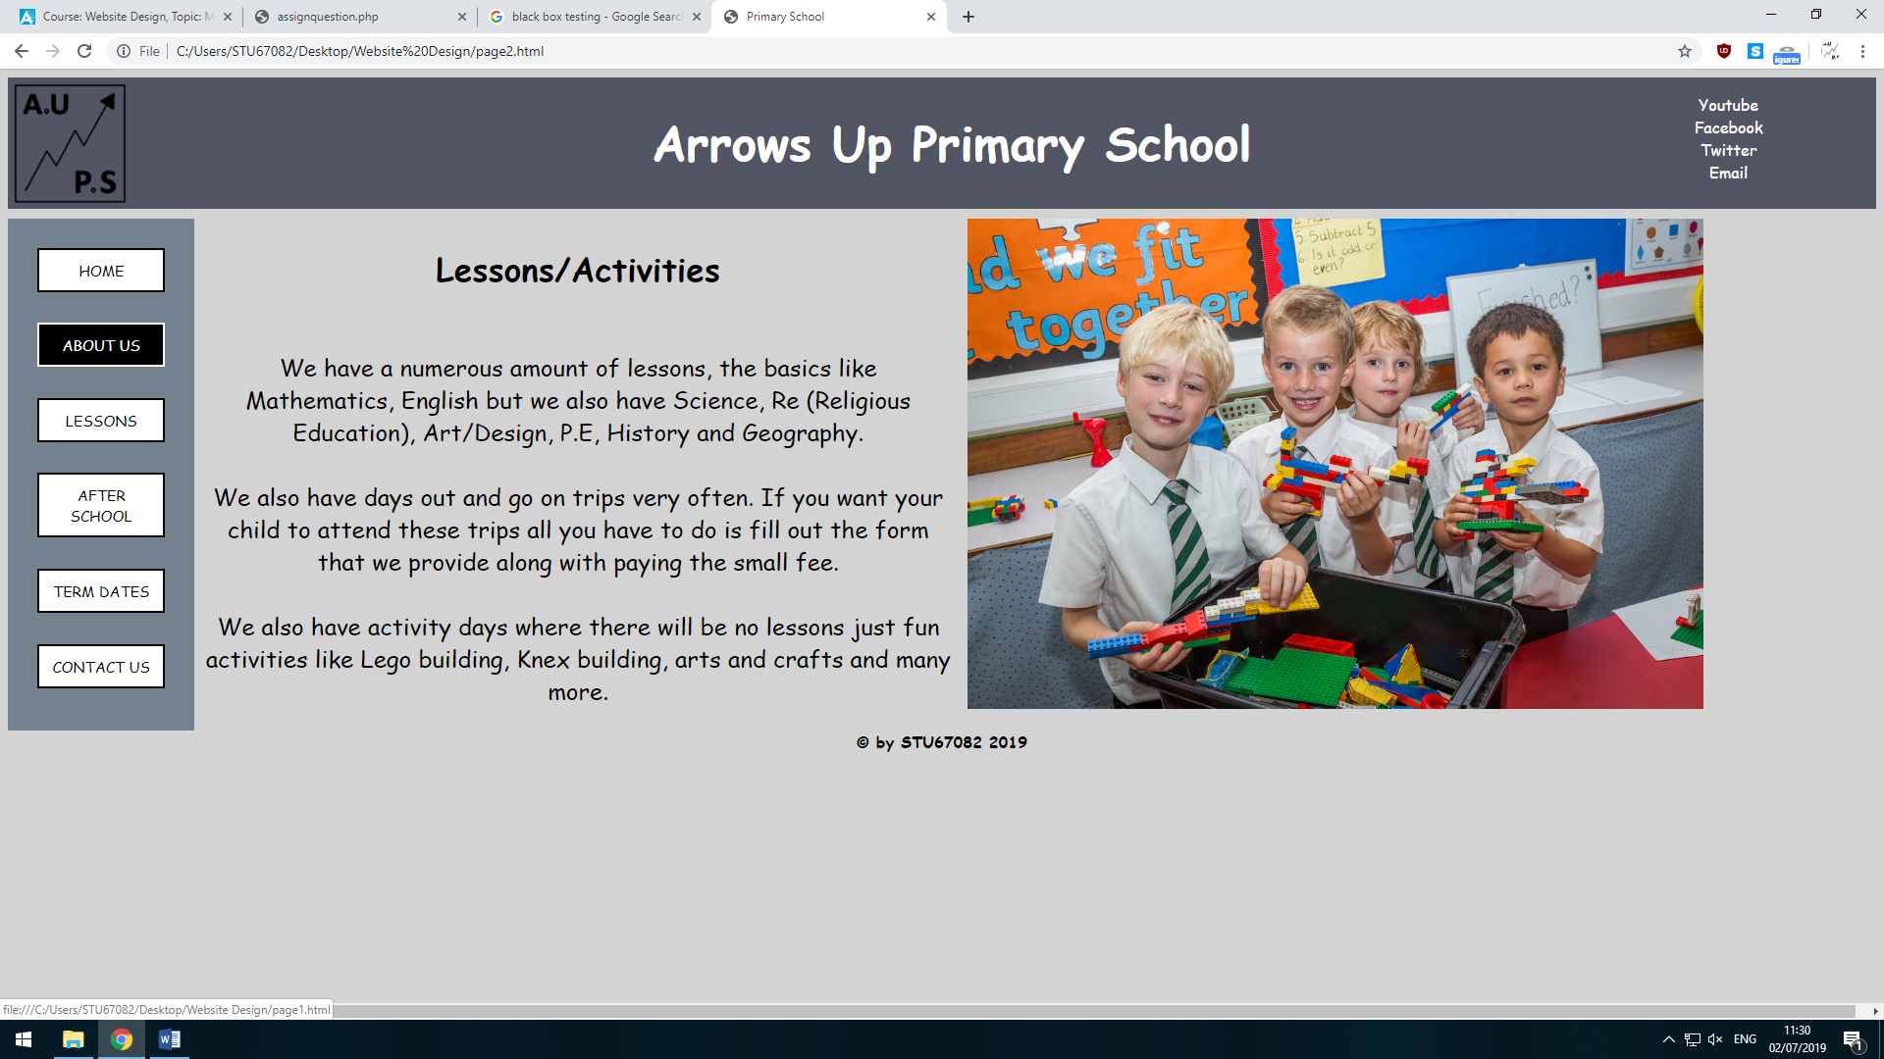

Links to social media for the school.

This is the navigation bar used to navigate through out the pages.

Informational picture with an alt text for each image.

Copyright for my website.

This is a paragraph of information regarding the subheading.

**Page 4**

This page has information about the after school activities.

This is the school logo that I created with paint.

This is the sub heading

This is the Title

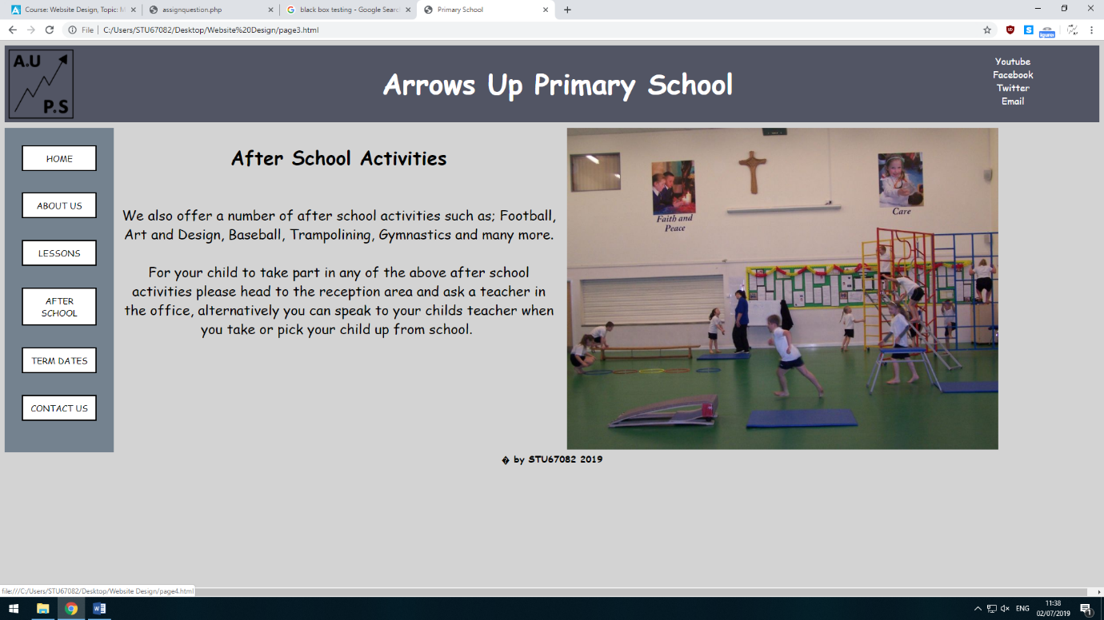

Links to social media for the school.

Informational picture with an alt text for each image.

This is a paragraph of information regarding the subheading.

This is the navigation bar used to navigate through out the pages.

Copyright for my website.

**Page 5**

Page 5 is about the different term dates this school has.

This is the school logo that I created with paint.

This is the Title

This is the sub heading

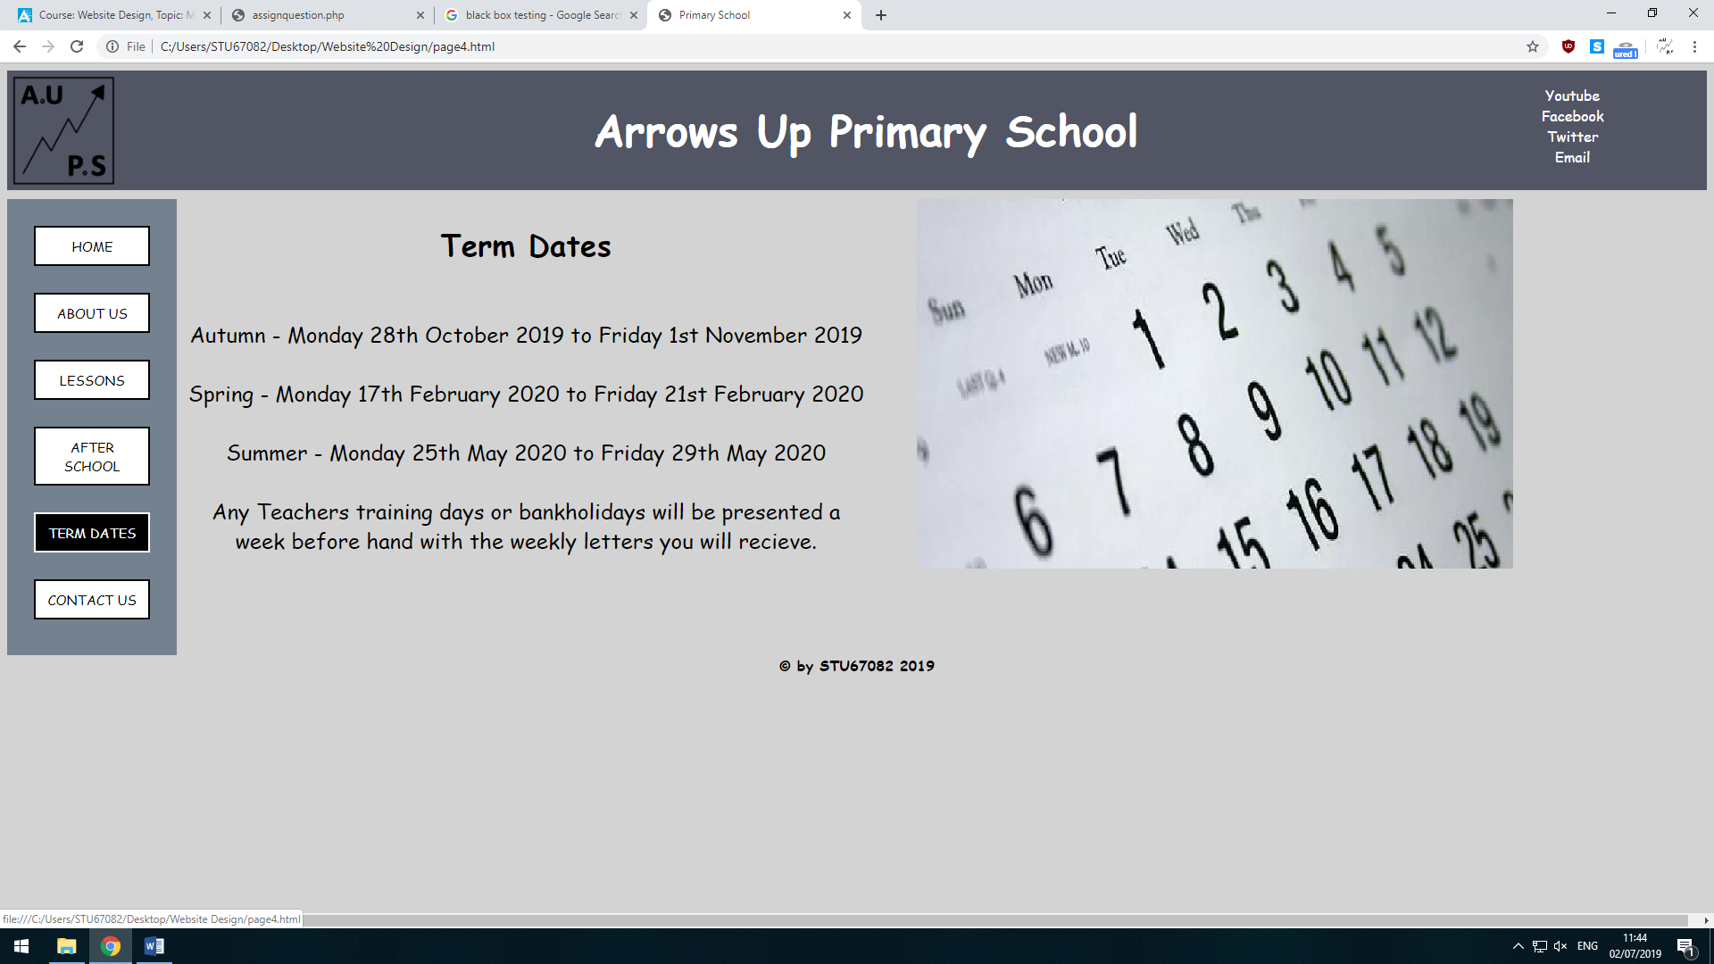

Links to social media for the school.

This is the navigation bar used to navigate through out the pages.

This is a paragraph of information regarding the subheading.

Copyright for my website.

Informational picture with an alt text for each image.

**Page 6**

Page 6 is the contact us page.

This is the school logo that I created with paint.

This is the sub heading

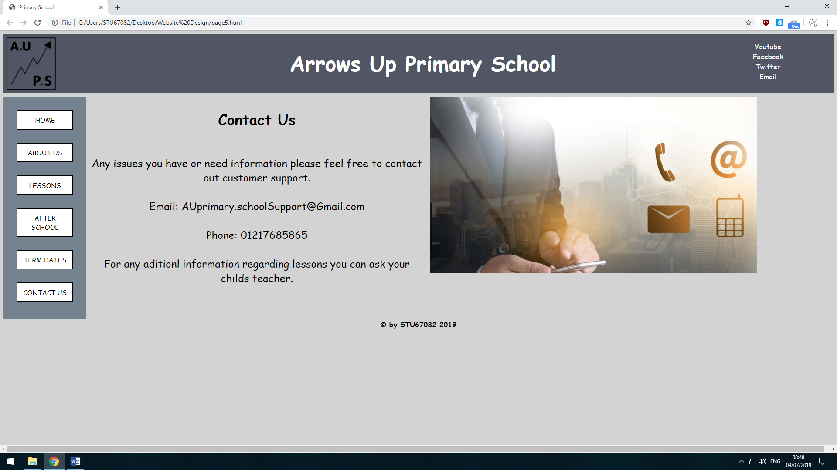

Links to social media for the school.

This is the Title

Informational picture with an alt text for each image.

This is the navigation bar used to navigate through out the pages.

Copyright for my website.

This is a paragraph of information regarding the subheading.

**Here is the code for my website**

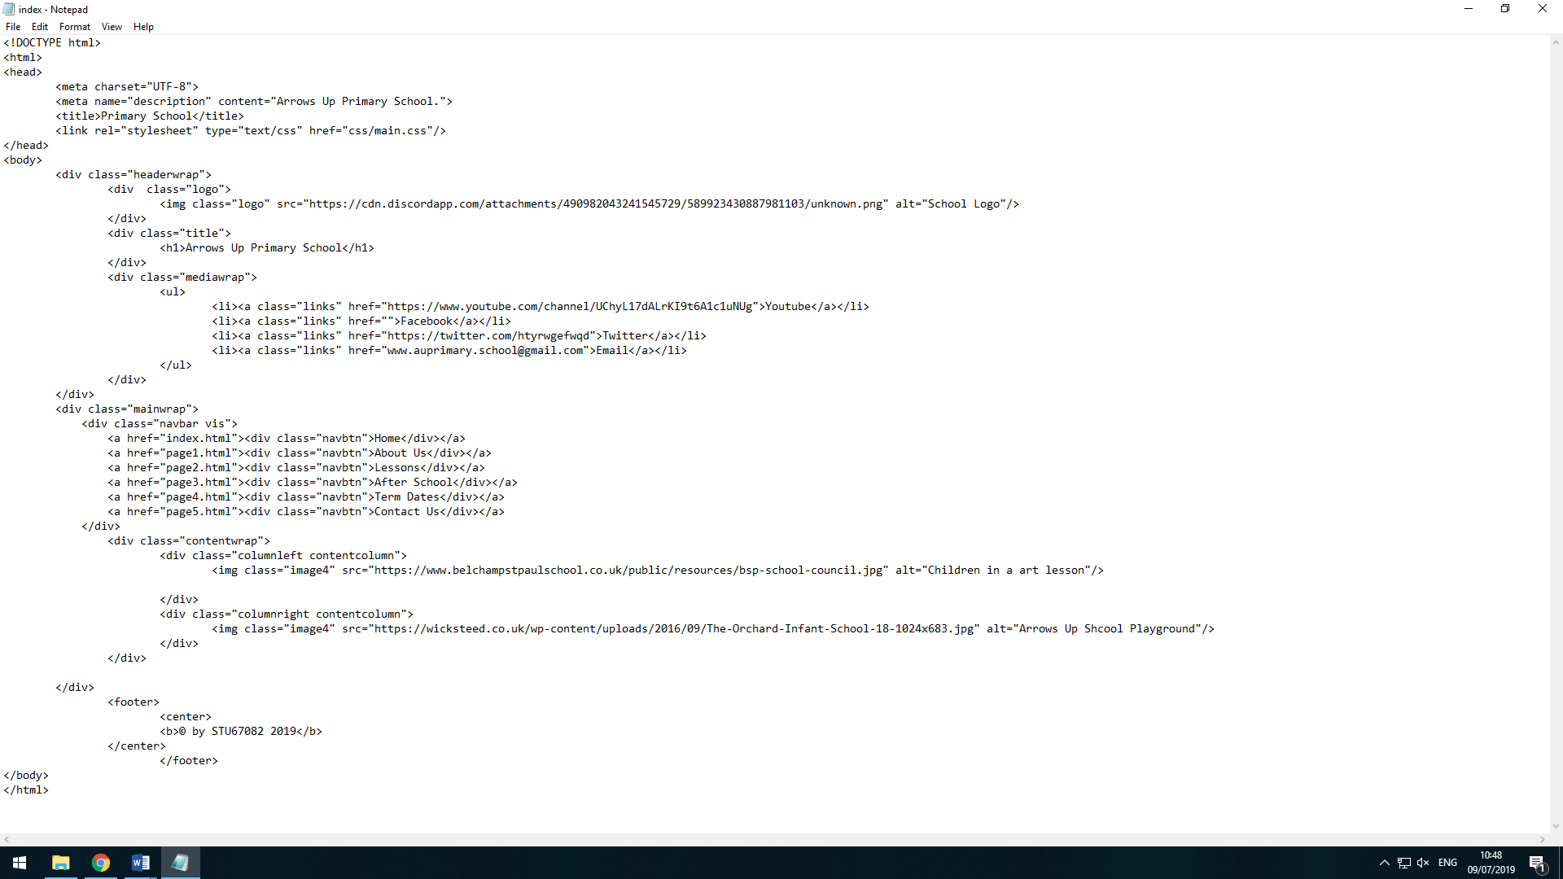

This is the code for the Home page which is slightly different than the rest of the pages.

**This is the other page’s code which is the same apart form the information on each page.**

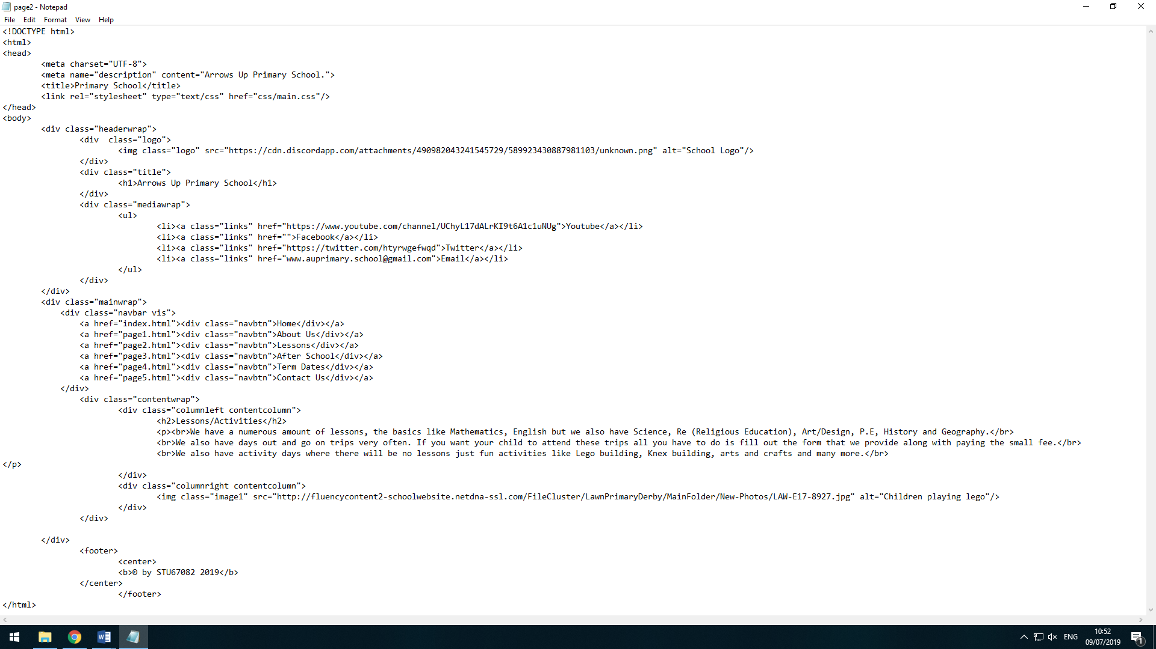

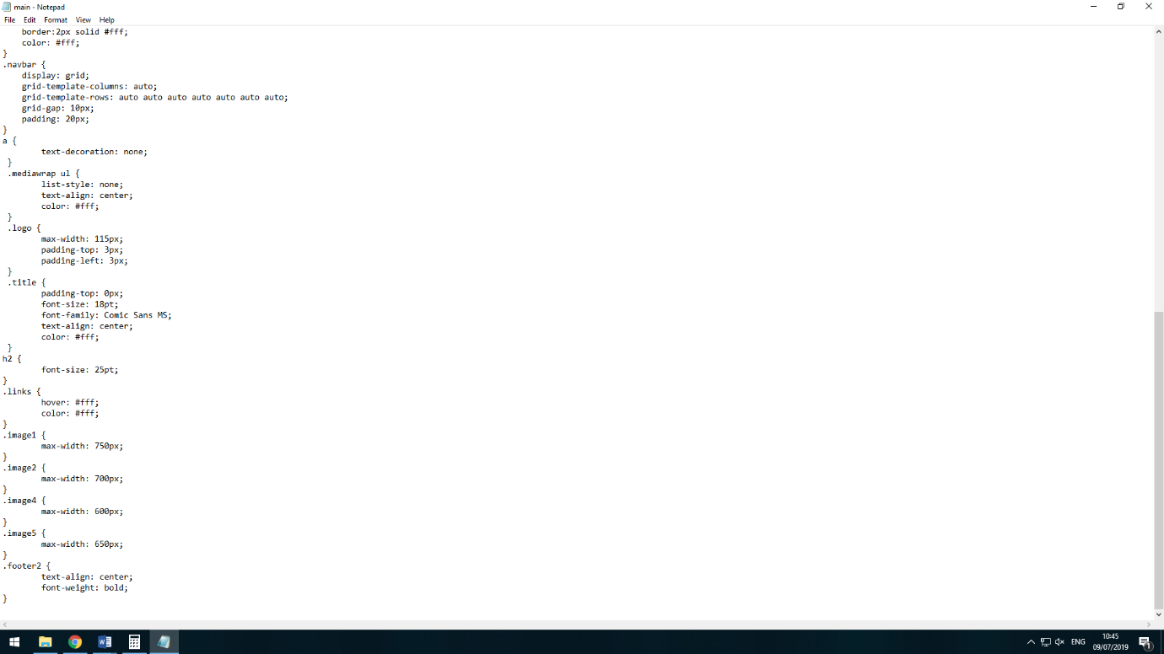**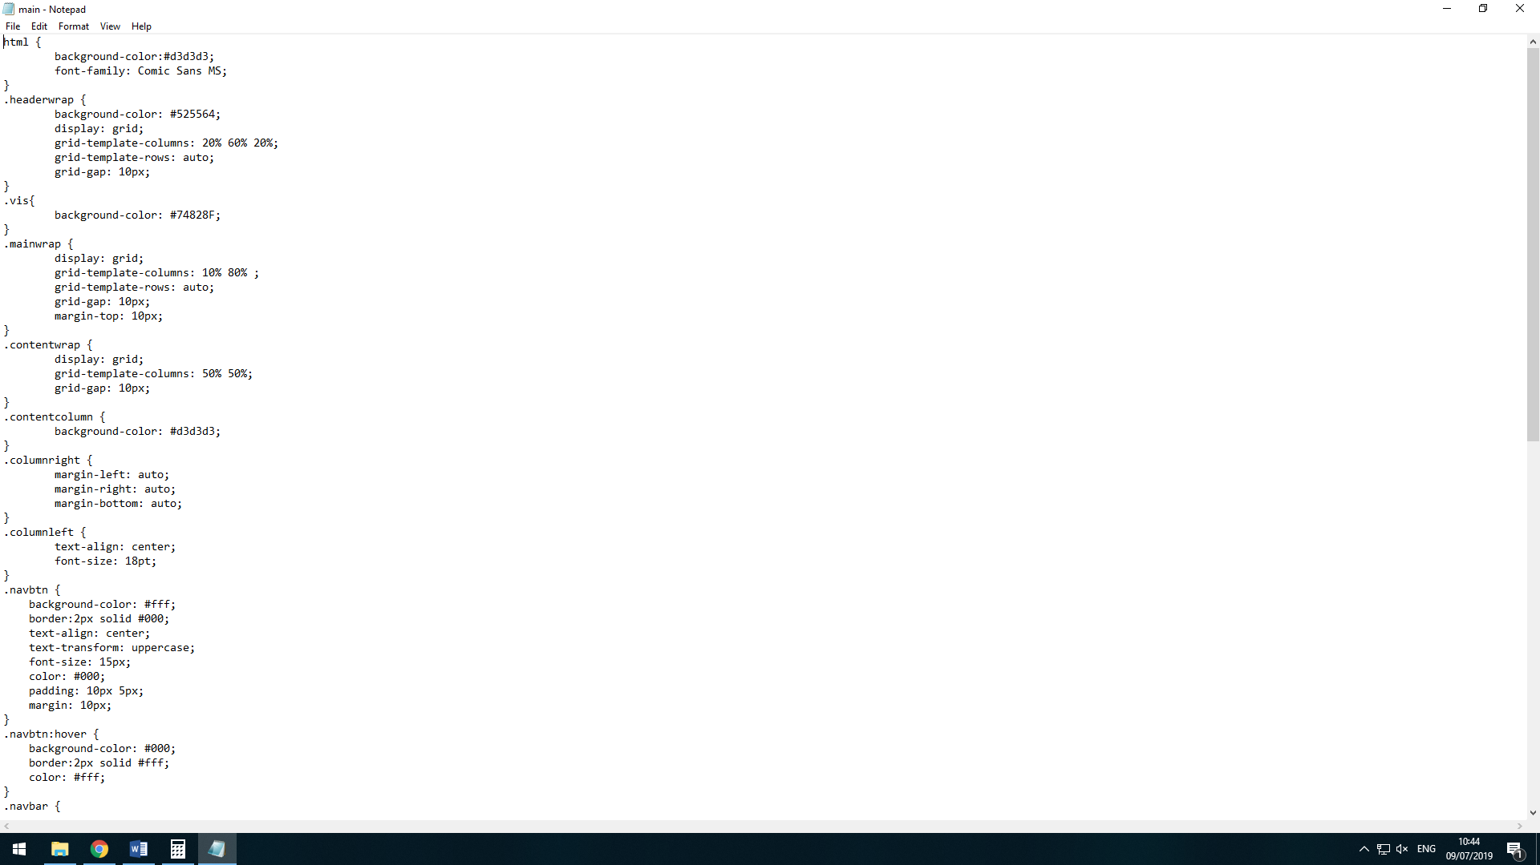This is my CSS sheet for all pages on my website**

**Task 6**

**Optimisation Word Count: 408**

I would go about this in many ways. One way would be to add a meta data tag to my website. This will give users a short but interesting information about my website before they click on it. “Metadata summarizes basic information about data, which can make finding and working with particular instances of data easier.” – (<https://whatis.techtarget.com/definition/metadata>)

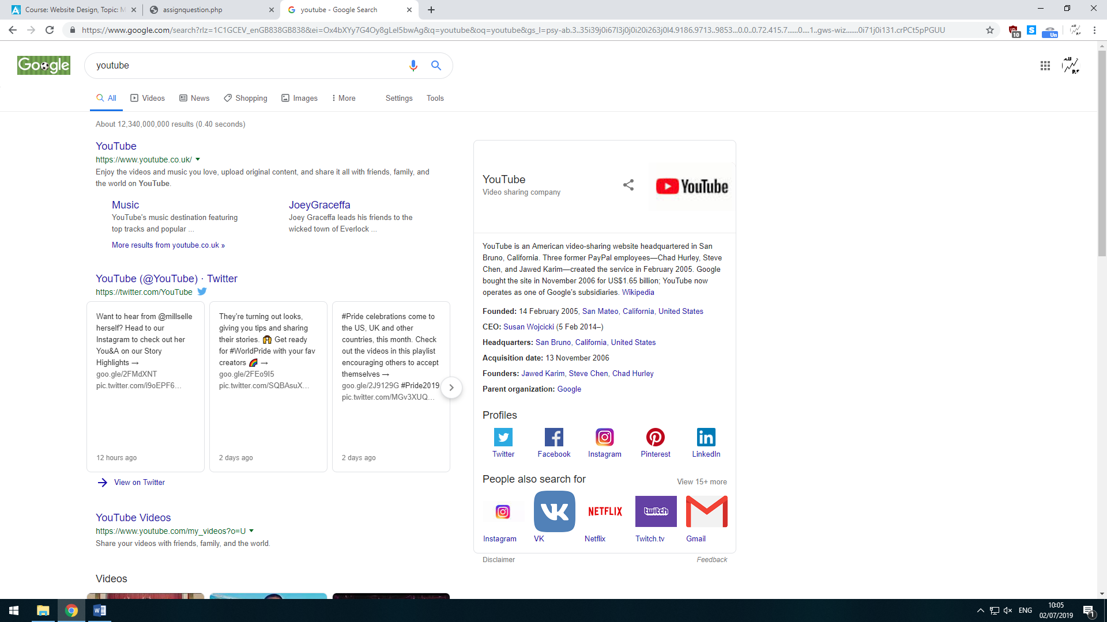

This short bit of information is Metadata

Doing this will make the user know what they are getting into when clicking on your website and can bring more traffic to the website.

Another way is to sign up and register to a site called GoogleMyBusiness with will make your website pop up in on the side of the page like this:

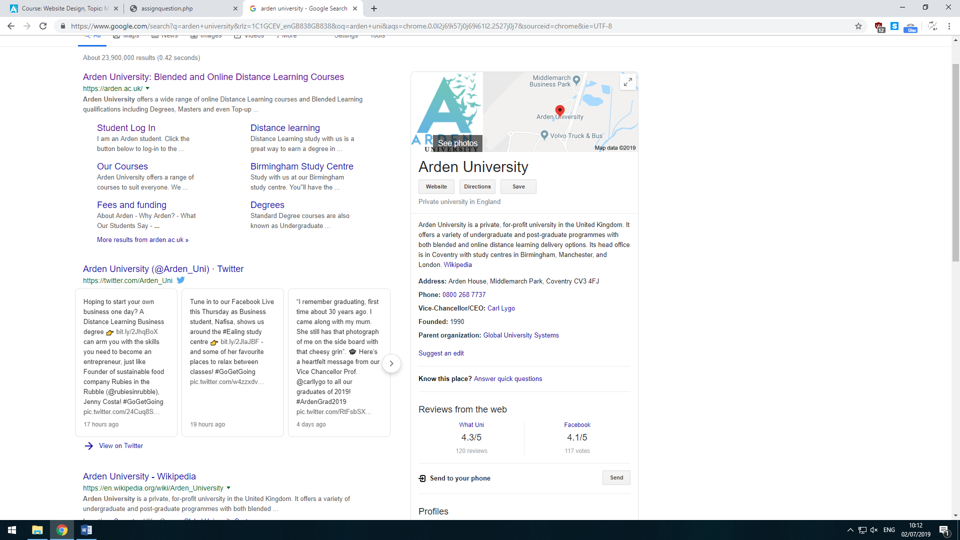This appears right next to all the links when you search for something and will give some basic info such as: Location, email, Phone number, Owner/CEO and also displays ratings and reviews. Doing this will allow users to rate and review your website and facilities. The way this helps you is if you get good ratings and reviews, you get more people wanting to visit and also boosts you up to the top in search results which brings more people to your website and facilities.

A lot of the people viewing websites in 2018-2019 is done by smartphone or tablet to make sure I don’t miss out on all these views for my website I would go onto something called TestMySite. This site will test the speed that an average phone would take to connect and load all the pages and how to increase speed and reduce byte size along with an evaluation of how much you would love in revenue from ads due to low connection speed.

When having ads on your website you want to make sure you choose the right ones for example you don’t want to have a website on different types of beds and then have an ad for snooker tables. You want to have similar ads that will benefit your users. For example, if your website is on different types of beds then it would be better for the customer to have ads for discounted beds for sale. If I was going to inert ads to my website, I would use GoogleAdSense. You can also use affiliate codes on your site to make some money. This way you can make some money with other people using your discount code on checkout at certain websites.

**References**

Software testing., (2013). Black Box Testing [online]. Software testing. [Viewed 2 July 2019]. Available from: <http://softwaretestingfundamentals.com/black-box-testing/>

Whatis Techtarget., (2013). Meta Data [online]. Whatis Techtarget. [Viewed 9 July 2019]. Available from: <https://whatis.techtarget.com/definition/metadata>